**14/06/2025**

**HTML (Hyper text mark up language):**

* Hyper text mark up language which help to create web pages.

HTML is not case sensitive. HTML provided lot of pre defined tags which help to display the content on web page in any format.

Html, head, body, title, p, div, span, form, font etc.

* Version 1.0 to 5.0

<https://www.google.com> -🡪 URL

http/https (req)---------🡪

Client Server

🡨---http/https (res) html or html 5 version

**Attribute :**

Attribute is known as properties of the tags. Every tag contains one more attribute. Attribute always we need to use in opening in the form of key-value pairs. Value can be in single or double or without quote.

Connecting one web page to another web page.

* Hyper link tag
* <a href=”pageName.html”>Click</a>

A 🡪 anchor

Href 🡪 hyperreference

**List tags:**

* Unorder List
* Order List

**CSS (Cascading style sheet)**

CSS provided lot of pre defined attribute in the form of key-value pairs which help to apply formatting style for web page.

Using CSS we can achieve separation of concern. Means actual content and formatting style we can write separately.

* **INLINE CSS:**

<tagName style=”property:value;property:value;”></tagName>

* **INTERNAL OR EMBEDDED CSS**

We need to write style tag inside head tag

Types of selector

1. * universal selector
2. specific tag selector
3. class selector

a. global class selector .className{property:value}

b. local class selector tagName.className{property:value}

* **EXTERNAL CSS**

**BOOTSTRAP**

React JS:

Html --🡪 Display the content on web page

Css 🡪 apply formatting style for web page

JS -🡪 coding on web page.

**REACT JS:**

React JS is a third party open source external JavaScript library provided by Facebook. Using React JS we can develop SPA (Single Page Application). React JS support component based architecture concept.

External JS file contains function (user defined function) which help to do some task.

In JS we need to write Lot of user defined function in internal or external JS file to do DOM Operation (read, write and update) html contents dynamically.

**JQUERY:**

jQuery is an external JS file. Means it contains lot of pre defined function which internally connected with each other to do DOM operation easily rather than we are writing explicitly.

* jQuery doesn’t follow standard.
* React JS: Library
* Angular Framework
* Vue JS Framework

**MULTI PAGE APPLICATION:**

Index.html welcome.html

Its own DOM it own html code its own DOM it own

Html, head, body, p, hyperlink or button html code

In multi page application when we move from one page to another page using hyper link or button or any other way the whole page or DOM get loaded once again from scratch.

**SINGLE PAGE APPLICATION:**

In Single page application we are loading only part of the web page rather than whole page. This concept we can achieve using AJAX.

React JS support Virtual DOM concept But Angular doesn’t support his concept.

Component is use to control the view or part of the view page. Using the component we can achieve re-usability concept.

Before component

Index.html

<header>content</header> or include header.html

footer.html

About.html

<header>content</header> or include header.html

Contact.html

<header>content</header>

Dashboard.html

<header>content</header>

Header.html

Footer.html

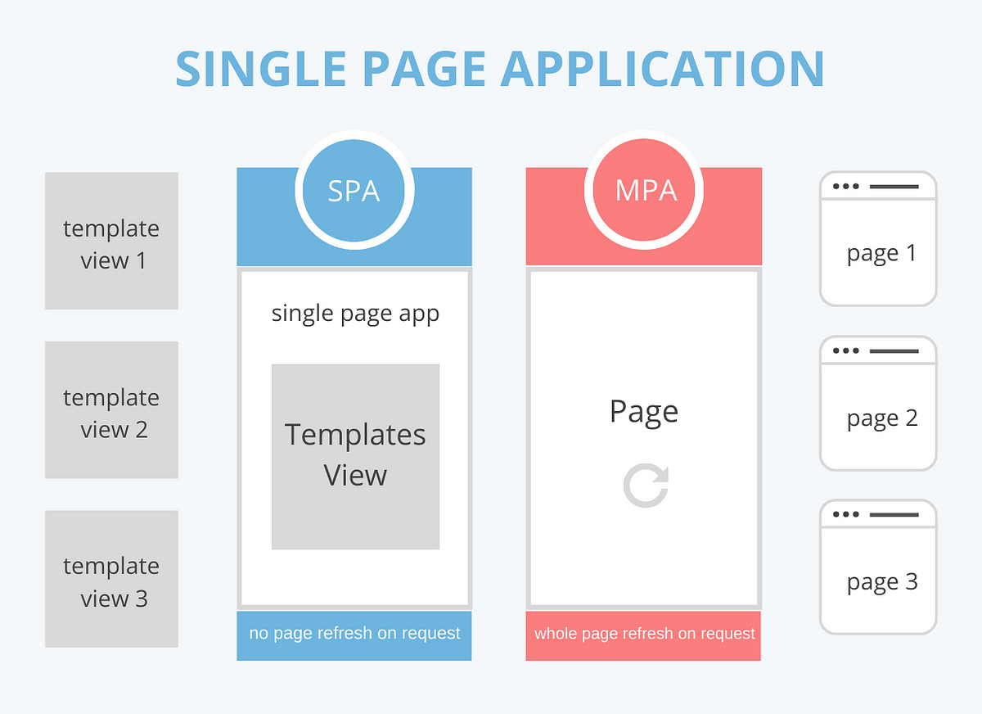

In React JS we can create React Component (Component is use to control the view or part of the view in web page) using

1. Function style component
2. Arrow style component
3. Class style component (ES6 features)

To create the React JS Application we need Node JS.

**NODE JS:**

Node JS is known as run time environment for JavaScript program or JavaScript library or Framework.

Before Node JS JavaScript known as Client Side scripting language But after node JS JavaScript also known as Client side as well as server side scripting language.

Node JS provided tool kit

As

npm (node package manager)

npx (node package extension)

node --version

npm --version

npx --version

creating react js project using npx command

npx create-react-app welcome-app

welcome-app is project name you can write anything depending upon your requirements.

It creates the project. After downloaded all file and folder you need to move inside a project directly using the command as

cd welcome-app

npm start this command is use to run the project